

AGATA DATABASE VIDEO CONFERENCE #1
05/03/2013- DRAFT [validated]
Present: O.Stézowski, C.Aufranc, G.Duchêne, X.Lafaye, N.Dosme, E. Clément, B. Million, M.Karolak, M.H.Sigward. R.Menegazzo
Excused: H.C Boston, A.Lotode
AGENDA

1 – Goals of such meetings
2 – Last news concerning the developments related to the DB (software, docs … etc)
3 – Tour of the different laboratories to collect the information that should be in the DB
(New information since around July 2012. If you have collected them please send them to agatadb@ipnl.in2p3.fr or even start updating the DB)
4 – Definition of the actions to update the DB
5 – Organization to have a DB updated continuously
6 – AOB, Any Other Business
Joined documents :
ADB_VC_05_03_2013_StatusElectronic.pdf

1 – Goals of such meetings
OS gave a short history of the DB. Partially filled at LNL, thus partially used moving AGATA from LNL to GSI. July 2012, situation in DB matched reality. Nothing done on DB since.
==> video conferences to :
- update again the AGATA DB
- more important to set up an active network so that DB is filled quickly/regularly.
OS : role of contact persons
- informed people of their laboratories a DB exists
- be informed by people in case something happens on real objects
- Update the DB accordingly
- or in difficulties report to DB administrator agatadb@ipnl.in2p3.fr
What is the job [minimum]
- any new object should be referenced : code bar on it + input in DB ... where it is produced !
- any modification of compositions do accordingly in the DB
- any transfer from one lab to another lab through the DB
- any broken/repaired object should be notified in the DB ... even just a comment

2 – Last news concerning the developments related to the DB (software, docs … etc)
CA made a description of developments done since July 2012
- some generic developments (more tooltips, ratio of filtered objects, faulty in red) + several new functionalities (typical photos of objects on clic, web browser called for URL).
It requires the re-installation of the BigBrowser interface
=> contact us via agatadb@ipnl.in2p3.fr in case of problems
- a plugin displays graphically the history of assembly of an object (Fig 1 at the end of the document) + possibility to move in time and see differences.
This plugin will soon be available, maybe in the future as default interface
Comments :
GD (discussion AGATA France) : interaction DB and topology manager (DAQ)
OS, CA, DAQ team to meet at the next AGATA week to restart it
Strasbourg : to check if better photos of patch boxes for the DB

3 – Tour of the different laboratories to collect the information that should be in the DB
- Lyon
  - Update on the capsules: all in the DB with current status (Fig2) + the owner action
=> the owner, the origin and the history of each capsule has been registered (Fig3)

  - Update of the clusters: creation of 1 new cluster, update of the composition of the clusters, update of their location => barcodes have to be sticked by GSI or Cologne on the endcaps/cryostats of ATC06, ADC02 and ADC03, registered and assembled in corresponding clusters. Lyon to send the corresponding barcodes

Comments :
DIFFICULT to update DB 'at distance', should be done from the labs working on objects

- Liverpool, Cologne, GSI : nobody there. F.Amiel currently working on updating the DB.
- Daresbury, producer of actual digitizers : No contact person yet !
Find one at the next AGATA week ?
- Strasbourg
  - New patch boxes available soon : bar code sheet to be delivered to them by Lyon.
Objects to be added in DB (sticked,referenced and transfer) by Strasbourg
  - Rods supporting the patch boxes : not an object in the DB, thus nothing to be done
  - Lost patch boxes. Lyon to ask F.Amiel which ones are lost. Lyon to set them as faulty.

- Padova
  - New digitizers : still developments, in DB only once produced.
  - BUT definition for DB to be established i.e.
object name (≡ DIGITIZER), object type, version + same for the all the subcomponents and definition of the composition. GD, digitizer = 5 cards in one module close to cryostat.
  - Impact of pre processing chain to be defined also ?
  - ND to meet people soon and pass also the information
- GANIL
  - LVPS bought by GANIL but sent directly to Saclay + ATCA power supply. Nabil K. to confirm the delivery place ?
- Saclay
  - CAT B013 on going : once finished transfer to be done in DB to the destination
(see later for CAT in DB)
  - New LVPS (ordered by GANIL) to be sent there :
bar code to be sent by Lyon, to be sticked and set in DB by Saclay
  - Two LVPS in the manufacturer, collected @ Saclay. Once back, to be written in the DB as repaired + transfer to destination.
- Orsay
  - Electronic cards : second production is missing in the DB. Cards dispached beetween Orsay and GSI.
XL to tell Lyon which ones and give information how they are assembled
  - ND : only linko to be transferred to Orsay. As not yet referenced in DB no transfer to be done. Should we referenced now the linco in the DB ?

4 – Definition of the actions to update the DB
see point 3

5 – Organization to have a DB updated continuously

GD and BM : keep visio conference every month. Short, about one hour.
BM : people to be informed @ the next agata week of this kind of meetings.
Each laboratory should organize itself the way to work around the DB contact person.
OS to propose a doodle week #13 (25-31 march)

6 – AOB, Any Other Business

None during the conference. Information on the owners of LVPS / Digitizers to be collected ?

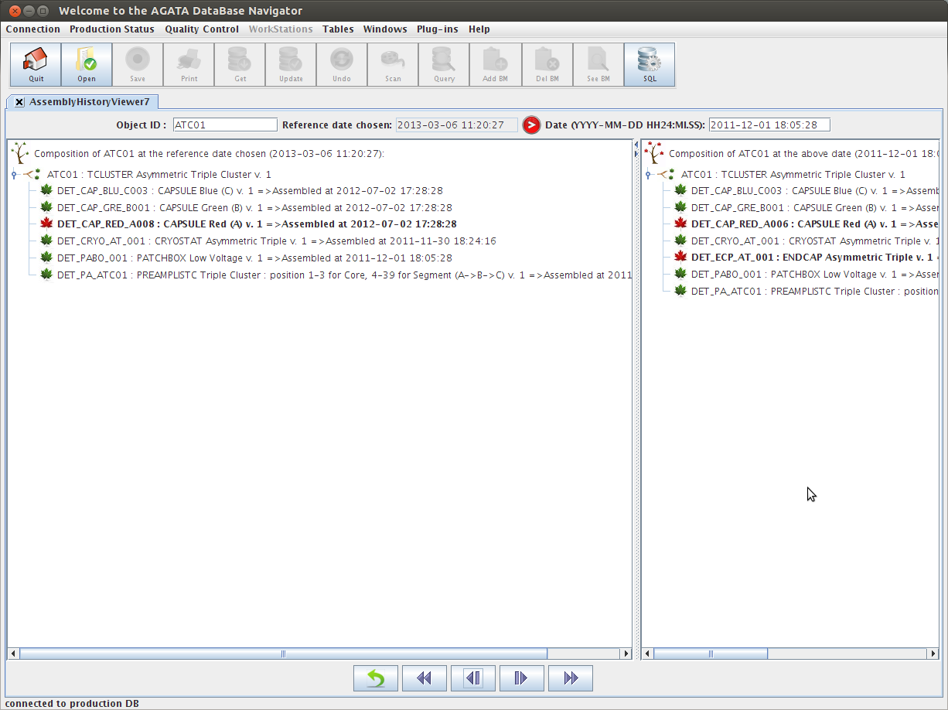1 . GUI to go through time and check assembly differences
2 . Status of crystals not assembled

3. Owners of crystals as known by the DB

AGATA DATABASE VIDEO CONFERENCE #2
25/04/2013- DRAFT [validated]
Present: O.Stézowski, C.Aufranc, B. Birkenbach, P. Coleman-Smith, D. Laff, D.Judson, G.Duchêne, E. Clément, M.H.Sigward, N.Dosme,
Excused: A.Lotode, M.Karolak, R.Menegazzo, X.Lafaye, B. Million
AGENDA

1 – Introduction
goal of the meeting, pending actions/questions
2 – Last news concerning the developments related to the DB (software, docs … etc)
3 – Tour of the different laboratories:
to collect the relevant information, to define the actions to be done
4 – General Organization
5 – AOB, Any Other Business
Joined documents :

1 – Introduction

OS explained goal of the meeting for the new participants. Presentation of the DB @ last AGATA Week available here or here
Pending actions:
Lyon:
endcaps/cryostats bar codes of ATC06, ADC02 and ADC03 to be sent @ GSI
ask Nabil K. to confirm the delivery place of ATCA power supply ?
Strasbourg:
photos on new patch boxes once sticked
Objects to be added in DB (sticked,referenced and transfer) by Strasbourg
*** Waiting for workshop ***
Padova:
definition of new digitizer for DB to be established [see this document, fig. 2]
Saclay:
B013 status ?
Are new LVPS arrived, sticked ? referenced ?
Are broken LVPS back from manufacturer ? repaired ? sent back ?
Orsay:
Information concerning electronic collected (xls sheet): in DB to be done

Questions:
Information on the owners of LVPS / Digitizers to be collected [see this document] ?
Definition of the new pre processing chain [see fig. 2 as starting point]

2 – Last news concerning the developments related to the DB (software, docs … etc)
development of the new panel (see fig. 1) is integrated soon as default in BigBrowser. Mailing system improved when using DB transfers.
Requirements for improving the interface: agatadb_AT_ipnl.in2p3
3 – Tour of the different laboratories to collect the information that should be in the DB
- Lyon
Detectors in DB updated using file produced by detector group (04/05/2013)
Better if done at the source ...
- Cologne / Liverpool
Organization has to be established inside the detector group to fill the DB
(to be discussed in the next detector meeting)
- GSI: FA has updated the DB since the previous meeting
- Strasbourg
Lost patch boxes found. Situation in DB is now ok for this
New boxes to be sent to Cologne for adding LN2 card (if possible) => DB transfer
Photos with bar codes to be produced and sent to Lyon
*** Waiting for workshop ***
Software update of digitizers to be done @ Strasbourg (Daresbury teaching)
=> DB transfer from GSI + information in DB
Scanning table should be in production for AGATA next summer
- Padova
- GANIL
EXOGAM DB used to teach engineers. Dedicated PC ordered for the GANIL campaign.
- Saclay
- Orsay
Information concerning electronic collected (xls sheet):
in DB to be done, see with Lyon
- Daresbury
2 digitizers @ Daresbury (PCS to check if bar codes on them, Lyon to send in case)
1 digitizers @ Orsay (ND to check if bar codes on them, Lyon to send in case)
2 digitizers @ LNL (Someone to check if bar codes on them, Lyon to send in case)
Work to have bar code – serial numbers in DB.
PCS to send email to ND, FA to established the correspondence. GD and PCS to determine the owner of the digitizers
Reminder concerning the current definitions for digitizers in DB.
A DIGITIZER (cooling frame) is composed of 2 DIGITIZERMOD, One SEG and one COR.
Object Type Version
DIGITIZER PROT 1
DIGITIZER COM 1
DIGITIZERMOD SEG 1
DIGITIZERMOD COR 1

4 – General Organization
Keep meeting every month, month and an half.
OS to set doodle in two weeks
5 – AOB, Any Other Business
Should be great to have test DB synchronized from time to time with production DB
parameters to connect to test/dev DB to be send to Daresbury

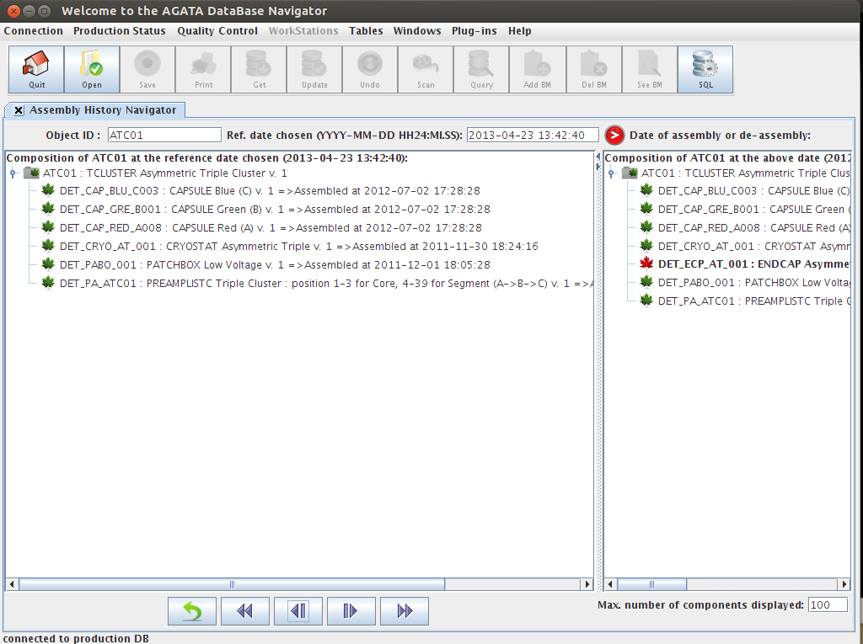1 . Final version of the GUI to go through time and check assembly differences

from Pullia's talk, 13th AGATA Week, GANIL 03/2013

DIGI-OPT12: 12-channel 14/16-bit 100/125-MS/s Digitizer with Optical Output for AGATA/GALILEO

AGATA DATABASE VIDEO CONFERENCE #3
10/06/2013- [VALIDATED]
Present: O.Stézowski, X.Lafaye, G.Duchêne, N.Dosme
Excused: C.Aufranc, B. Million, P. Coleman-Smith, D. Laff, R.Menegazzo, D.Judson, L.Menagern
AGENDA

1 – Introduction
pending actions/questions
2 – Last news concerning the developments related to the DB (software, docs … etc)
3 – Tour of the different laboratories:
to collect the relevant information, to define the actions to be done
4 – General Organization
5 – AOB, Any Other Business
Joined documents :

1 – Introduction

Pending actions:
Lyon:
Strasbourg:
photos on new patch boxes once sticked
Objects to be added in DB (sticked,referenced and transfer) by Strasbourg
*** Waiting for workshop ***
Padova:
definition of new digitizer for DB to be established
A.Gadea to give a description (from last infrastructure meeting)
Saclay:
B013 status ?
Are new LVPS arrived, sticked ? referenced ?
Are broken LVPS back from manufacturer ? repaired ? sent back ?
Orsay:
Information concerning electronic collected (xls sheet): in DB to be done

Questions:
Information on the owners of LVPS / Digitizers to be collected
Definition of the new pre processing chain

2 – Last news concerning the developments related to the DB (software, docs … etc)
The new interface (see picture) being developed is mentioned and explained.
The aim is to provide a simple graphical interface to add informations (CAT test, owner) on objects. It allows field by field to get old values and put new ones.
It should be operational before holidays.
Requirements for improving the interface: agatadb_AT_ipnl.in2p3
3 – Tour of the different laboratories to collect the information that should be in the DB
- Lyon
Code bar delivered to different groups + some update in DB
- Cologne / Liverpool
- GSI: FA has updated the DB since the previous meeting
- Strasbourg
Test LN2 card and BSD (Bias Shut Down) in patch boxes necessary and to be done @ Cologne and GSI => Required Transfer and Special actions in DB to keep track of this!
Access to the interior required. Strasbourg workshop to drill the patch boxes to allow that
Most probably in september.
- Padova
- GANIL
- Saclay
- Orsay
Information regarding the electronic cards collected. Still to be added to the DB
Test on the digitizers to be done and results sent to Patrick :
Code bar to be sent to Orsay (first check if there are already some sticked on them)
- Daresbury

4 – General Organization
Next meeting for September.
5 – AOB, Any Other Business

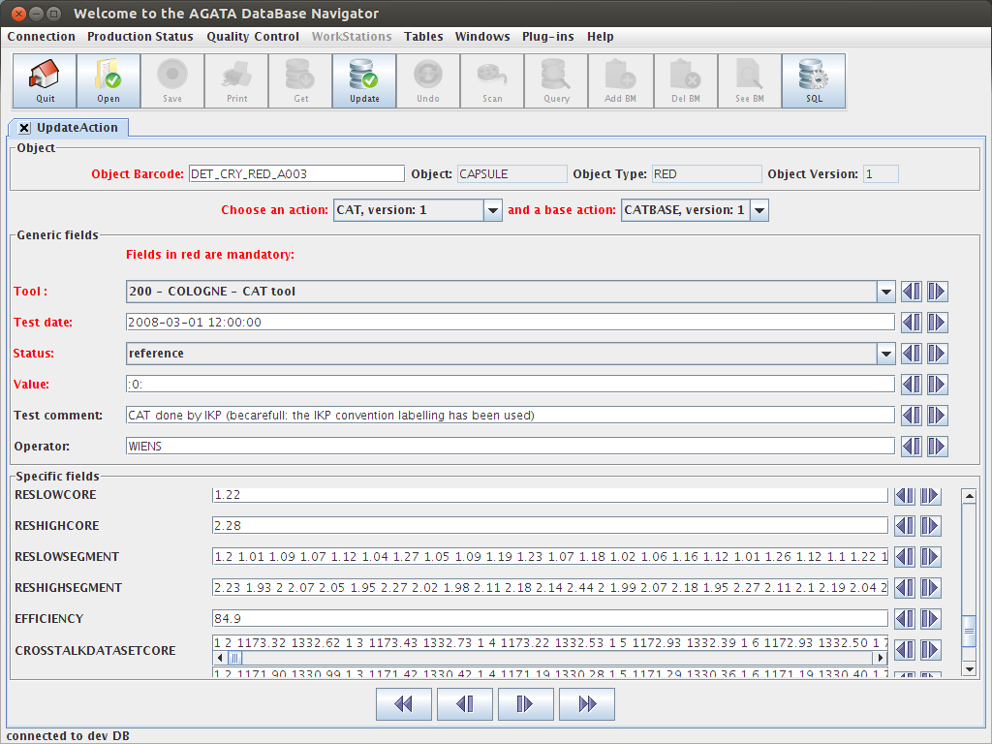

AGATA DATABASE VIDEO CONFERENCE #4
08/10/2013- [VALIDATED]
Present: O.Stézowski, X.Lafaye, G.Duchêne, N.Dosme, M. Karolak, M.H.Sigward, B. Million
Excused: C.Aufranc, D.Judson, B.Birkenbach
AGENDA

1 – Introduction
pending actions/questions
2 – Last news concerning the developments related to the DB (software, docs … etc)
3 – Tour of the different laboratories:
to collect the relevant information, to define the actions to be done
4 – General Organization
5 – AOB, Any Other Business
Joined documents :
A- DB snapshots concerning the work done the last month.
B- Proposal for new electronic / digitizer ... to be validated

1 – Introduction
Pending actions:
Lyon:
Strasbourg:
photos on new patch boxes once sticked
Objects to be added in DB (sticked,referenced and transfer) by Strasbourg
*** Waiting for workshop ***
Patch boxes: Required Transfer and Special actions in DB to keep track of this!
Strasbourg workshop to drill the patch boxes to allow that
Most probably in september.
Padova:
definition of new digitizer for DB to be established
A.Gadea to give a description (from last infrastructure meeting)
Saclay:

Orsay:
Information concerning electronic collected (xls sheet): in DB to be done

Daresbury:
Collection of informations: IP versus Barcodes, owner of digitizer to be done.
Then information to be added in DB

Questions:
Definition of the new pre processing chain

2 – Last news concerning the developments related to the DB (software, docs … etc)
Internal meeting (Lyon) in September to establish a roadmap concerning BigBrowser.
No important developments foreseen before next year but some quick improvements possible
3 – Tour of the different laboratories to collect the information that should be in the DB
- Lyon
Waiting for answer from A.Gadea concerning new electronic + new DB contact person in Valencia
in order to add new definitions to the DB
==> mail to be sent by O.S
- Cologne / Liverpool
- GSIA haV updated the DB since the previous meeting
- Strasbourg
Still waiting for Patch boxes and where to drill ... work foreseen in September - DELAYED
Digitizer to be upgraded (new channel for low gain). 1Full asked to GSI + 5 Core Cards, Transfer in DB to be done by F.Ameil
Strasbourg to take delivery + SPECIAL Action to indicate the upgrade + transfer back GSI
DB Work foreseen next year concerning scanning of Capsule
New mechanics for GANIL ... to be checked if new pieces in DB: ANSWER IS NO !
- Padova
- GANIL
- Saclay
B013 final report available. All information (Owner) have been set in DB (see snapshot A1)
LVPS_200_003 and _005 repaired (see snapshot A2-3)
LVPS crates 015, 016, 017 registered and fully assembled in DB. @ GSI now also in DB
Transfer [named “Shipping on 2013-10-04 by Ivan's car”] of 7 LVPS modules

GSI to take delivery
It remains 5 LVPS to be modified.
- Orsay
DAQ : Possible new material to be added ... code bar to be produced in case
--> do not hesitate to tell Lyon as soon as possible.
Electronic: Few carrier cards has been transported from for repair -> DB to be updated.
- Daresbury
Digitizer at ORSAY ... test not done yet.
OS to contact Daresbury for news.
Information from G.D: at least 8 digitizers bought by England + 3 by Italy

4 – General Organization
Next meeting: doodle to be sent mi november.
Snapshot of the DB activity every month in meeting's notes.

5 – AOB, Any Other Business
Some News for last Management board:
Next AGATA Week most probably in MADRID 22-24 January 2014
A lot of pressure around detectors especially because they warm up in July:
Not tested since, 3 TC to be checked. Detectors are still @ GSI.
B. Bruyneel is going to leave the AGATA community in January 2014
Money to be found [ENSAR] so that H. Hess could keep on working at cologne
Production of the new electronic is going on following the initial planning
Currently backplane of new digitizers tested by Spanish people:
--> Should be finished by the end of 2013 + software for the cards first part of 2014.
GTS upgrade only for GANIL
Reflexion around future R&D. ASIC Ge, replacement of flash ADC 16 bits / 100Mhz etc..
--> England ask for money for new electronic. Possibly in 2015
NARVAL School November 2013
Run characterization to be done [to check simulation] :
wait for detector + electronic to be operational ... no date fixed so far

Annex A: DB snapshots related to the work done in DB the last month
CAT RESULT for Capsule B013
ALL Actions in DB for the last month
Repaired LVPS_200 modules 003 and 005

Annex B:
Proposition for new digitizer / electronic ... to be validated + some questions to be answered

AGATA DB convention for the new digitizers and the new preprocessing chain
(Advanced Phase 1)

C. Aufranc, O.Stézowski
Version 1 – 3/07/2013

In the DB, any kind of object is described with the two triplets (short characteristics, longer description)
[object,type,version] [object description,type description,version description]

and all objects have a barcode sticked on it, thus a coding convention is required
[barcode pattern]

1. DIGITIZERS

For actual digitizers (early phase 1)

[DIGITIZER,COM,1] [Digitizer,Cooling Mechanics, Version 1] [DPS_DIG_XXX]
[DIGITIZERMOD,SEG,1] [Digitizer module, Segment Card, Version 1] [DPS_DIG_SEG_XXX]
[DIGITIZERMOD,COR,1] [Digitizer module, Core Card, Version 1] [DPS_DIG_COR_XXX]

A DIGITIZER is composed of two DIGITIZERMOD, one SEG and one COR

With for DPS_DIG_XXX
XXX < 100 corresponds to previous way of setting barcode for cooling frame (mic mac @ GSI)
100 < XXX < 200 current situation

→ Proposition for new digitizers (advanced phase 1) :

[DIGITIZER,UNIT,1] [Digitizer, Digitizer Unit, Version 1] [DPS_DIG_XXX]
[DIGITIZERMOD,CTR,1] [Digitizer module, Control card EDA-02482-V2-0, Version 1] [DPS_DIG_CTR_XXX]
[DIGITIZERMOD,CADC,1] [Digitizer module, Core Card DIGI-OPT12, Version 1] [DPS_DIG_CADC_XXX]
[DIGITIZERMOD,SADC,1] [Digitizer module, Segment Card DIGI-OPT12, Version 1] [DPS_DIG_SADC_XXX]

Are there two types of cards for Core and Seg ? if so one can have CADC and SADC

A DIGITIZER unit is composed of 4 ADC cards and one Control Card
position 0 : Core Card
position 1 : Control Card
position 2-3-4 : Segment Card

DPS_DIG_XXX with XXX starting from 201

Of course it could be different. One can say the new unit is just version 2 of the first one [DIGITIZER,COM,2] [Digitizer, Cooling Mechanics, Version 2]
As it is really different things it makes no sense for us but it is not on the DB side to decide this ...

2. PCI preprocessing module

For actual pre processing chains (early phase 1)

In DB is defined a Preprocessing chain for a capsule

[PPECAPS,PHASE1,1][Pre-processing Electronic Chain for a Capsule, LEGNARO Phase,Version 1] [DPS_PP_CAPS_XXX]
[PPECAPS,PHASE1,2] [Pre-processing Electronic Chain for a Capsule,LEGNARO Phase,Version 2] [DPS_PP_CAPS_XXX]

- It is a virtual envelop so far containing real objects (electro. cards) which are used to process one capsule
- It contains PPECARDS
- NEVER used so far in DB !!! ...

The current cards are :

[PPECARD,CORM,1] [Pre-Processing Electronic Card, Core Mezzanine,Version 1] DPS_PP_CORM_XXX
{PPECARD,SEGM,1] [Pre-Processing Electronic Card, Segment Mezzanine,Version 1] DPS_PP_SEGM_XXX
[PPECARD,GTSM ,1] [Pre-Processing Electronic Card, GTS Mezzanine, Version 1] DPS_PP_GTSM_XXX
[PPECARD,TCLK,1] [Pre-Processing ElectronicCard, TCLK Card, Version 1] DPS_PP_TCLK_XXX
[PPECARD,LIN1,1] [Pre-Processing Electronic Card, LINCO-1 Card, Version 1] DPS_PP_LIN1_XXX
[PPECARD,LIN2,1] [Pre-Processing Electronic Card, LINCO-2 Card, Version DPS_PP_LIN2_XXX

A [PPECAPS,PHASE1,1] contains :
2 PPECARD ACAR 1
1 PPECARD TCLK 1
2 PPECARD LIN1 1

A [PPECAPS,PHASE1 2] contains :
2 PPECARD ACAR 1
1 PPECARD TCLK 1
1 PPECARD LIN2 1

→ Proposition for new Pre-Processing chain :

One can define a new PPECAPS
[PPECAPS,PHASE2,1] [Pre-processing Electronic Chain for a Capsule,GANIL Phase,Version 1] [DPS_PP_CAPS_XXX]

One can adopt the same philosophy for the bar code convention i.e.
XXX -> [100,200] for Preprocessing chain of type PHASE1
XXX -> [200,...] for Preprocessing chain of type PHASE2

containing
[PPECARD PCI 1] [Pre-Processing Electronic Card, PCI EDA-02266-V2, Version 1] DPS_PP_PCI_XXX
[PPECARD PCIPLUG 1] [Pre-Processing Electronic Card, PCI Plug EDA-02264-V2, Version 1] DPS_PP_PCIP_XXX

NOTE :
Is EDA-02264-V2 the PCI Board or the Plug ? (email exchange with numbers reversed)
Is the PCIPLUG included in the PCI Board (assembly in term of DB)
Is a PCI Board pluggued into something ?

Is this card a mezzanine card Are there type of cards (core,mezzanine) ? Is this card in a ATCA crate or VME ?

AGATA DATABASE VIDEO CONFERENCE #5
15/11/2013- [VALIDATED]
Present: C.Aufranc, B.Birkenbach, E. Clément, G.Duchêne, N.Dosme, M. Karolak, R. Menegazzo, M.H.Sigward, Secretary: O.Stézowski
Excused: F.Ameil, M.D.Salsac,
AGENDA

1 – Introduction
actions performed since last meeting / pending questions
2 – Last news concerning the developments related to the DB (software, docs … etc)
3 – Tour of the different laboratories:
to collect the relevant information, to define the actions to be done
4 – General Organization
5 – AOB, Any Other Business
Joined documents :
A- DB snapshots concerning the work done since the last meeting.
B- Proposal for new electronic / digitizer ... to be validated

1 – Introduction
Actions performed since last meeting:
Lyon:
mail sent to A. G. to fix definition of the new electronics+contact person@Madrid
mail to Daresbury for news on digitizers [IP or MAC versus Barcode]

Cologne:
GSI:
Transfer Digitizer to Strasbourg initiated + Take delivery of LVPS from Saclay

Strasbourg:
To take delivery of digitizer transfer (one cooling + 6 core cards)

Padova:
Saclay:

Orsay:
Information concerning electronic collected (xls sheet): in DB to be done ...

Daresbury:

Pending Questions:
Definition of the new pre processing chain

2 – Last news concerning the developments related to the DB (software, docs … etc)
A dedicated bar code printer is going to be bought by Lyon.
Should be able to provide stickers easy to produce and stick, with logos added together with the bar code.
Should be resistant in temperature / humidity.
No development on the GUI since last meeting but light modifications foreseen in the coming months
3 – Tour of the different laboratories to collect the information that should be in the DB
- Lyon
Pending from previous meeting:

Updates on detectors (see also snapshots):
general overview (crystal status & composition) identical between doc in Koln and DB
Are B010 and C010 still in ATC03 and ADC02 ? => B.B to see + de assembly in case
Quid detector A0040 ? Bought by Darmstadt, not AGATA ==> Not in ADB
Symmetric capsules not in DB ? Test Cryostat ?
=> Information to be collected by Koln,
=> bar code to be delivered for Test Cryostat by Lyon (@next AW)

- Liverpool
Pending from previous meeting:

- Cologne
Pending from previous meeting:

ATC03 repaired. Transfer to be done to GSI + in DB
One crystal@GSI [C010] should be sent quickly back to Canberra for repair
(still under guarantee)
Definition of the CAT test to be validated for production database
=> Lyon to send email with last version, B.B to validate

- GSIA haV
Pending from previous meeting:
updated the D
LVPS_200_002, the front face has been damaged during the transfer => Special in DB
Henning to manage and see whether or not modules to be sent back to Saclay
Assembly of LVPS modules to be done in DB to match real life + stick new bar codes on cooling frames.

Digitizer Core received from Strasbourg. Under test to validate. Keep date and Status of the test in order to set in DB ONCE Strasbourg has done the job for that digitizer [COR_002].

Orsay people at GSI beginning of december to test and validate VHDL1. Once done on the cards, to be done in DB [Special action].

- Strasbourg
Pending from previous meeting:
photos on new patch boxes once sticked
Patch boxes to be added in DB (sticked,referenced and transfer) by Strasbourg
*** Waiting for workshop ***
Patch boxes: Required Transfer and Special actions in DB to keep track of this action
[Strasbourg workshop to drill the patch boxes to allow that]
For Digitizers :
SPECIAL Action to indicate the upgrade + transfer back GSI

Six core + one cooling [digitizers] frame received from GSI. Tests are done before and after
modifications to add the additional channel.
CORE_002 modified and sent back to GSI. GSI to make validation test also.
Pb have been seen requiring to add an additional mylar foil. Going to be done on others.
History of modifications to be added in DB. See also with Lyon to see how.
Ask for new bar code stickers to be sticked on the new front panel => Lyon to send
The next Six core digitizers should come soon. GSI to be aware to set transfer

New mechanical piece for GANIL phase received by Friday. It has been decided to keep it in DB as MISCELLANEOUS object for traceability. Consistent bar code to be defined.

- Padova
Pending from previous meeting:
definition of new digitizer for DB to be established
A.Gadea to give a description (from last infrastructure meeting)

Audit as required by Daresbury has been on the digitizer used at Padova. No bar code on it.
Digitizer sent back to Daresbury for upgrade. Bar code to be sticked by them.

Currently no pieces for the new electronic to be sticked and set in DB.

- GANIL
Pending from previous meeting:

Bar code reader + dedicated PC now operational for the AGATA @ GANIL campaign.

- Saclay
Pending from previous meeting:

LVPS_200__002 _004 and _010 sent by DHL to GSI. Pb during transfer. GSI to investigate consequences, add info in DB and send back to Saclay if required
Insurance may be in game to cover repairs.

- Orsay
Pending from previous meeting:
Electronic: Few carrier cards have been transported from GSI for repair
=> DB to be updated.
Information concerning electronic collected (xls sheet): in DB to be done

There are cards currently being repaired. Back to GSI on december.
=> Operations performed should be written in DB.
At GSI, upgrade to VHDL1 to be written also in DB

- Daresbury
Pending from previous meeting:
Collection of informations: IP [MAC ?] versus Barcodes, owner of digitizer to be done.
Then information to be added in DB

Information from G.D: at least 8 digitizers bought by England + 3 by Italy

4 – General Organization
Next meeting: beginning of next year.
A summary of the year to be sent by email by the end of the year.

5 – AOB, Any Other Business

Annex A: DB snapshots related to the work done in DB since previous meeting
Inventory

transfers
4 transfers since last meeting

Annex B:
Proposition for new digitizer / electronic ... to be validated + some questions to be answered

AGATA DB convention for the new digitizers and the new preprocessing chain
(Advanced Phase 1)

C. Aufranc, O.Stézowski
Version 1 – 3/07/2013

In the DB, any kind of object is described with the two triplets (short characteristics, longer description)
[object,type,version] [object description,type description,version description]

and all objects have a barcode sticked on it, thus a coding convention is required
[barcode pattern]

1. DIGITIZERS

For actual digitizers (early phase 1)

[DIGITIZER,COM,1] [Digitizer,Cooling Mechanics, Version 1] [DPS_DIG_XXX]
[DIGITIZERMOD,SEG,1] [Digitizer module, Segment Card, Version 1] [DPS_DIG_SEG_XXX]
[DIGITIZERMOD,COR,1] [Digitizer module, Core Card, Version 1] [DPS_DIG_COR_XXX]

A DIGITIZER is composed of two DIGITIZERMOD, one SEG and one COR

With for DPS_DIG_XXX
XXX < 100 corresponds to previous way of setting barcode for cooling frame (mic mac @ GSI)
100 < XXX < 200 current situation

→ Proposition for new digitizers (advanced phase 1) :

[DIGITIZER,UNIT,1] [Digitizer, Digitizer Unit, Version 1] [DPS_DIG_XXX]
[DIGITIZERMOD,CTR,1] [Digitizer module, Control card EDA-02482-V2-0, Version 1] [DPS_DIG_CTR_XXX]
[DIGITIZERMOD,CADC,1] [Digitizer module, Core Card DIGI-OPT12, Version 1] [DPS_DIG_CADC_XXX]
[DIGITIZERMOD,SADC,1] [Digitizer module, Segment Card DIGI-OPT12, Version 1] [DPS_DIG_SADC_XXX]

Are there two types of cards for Core and Seg ? if so one can have CADC and SADC

A DIGITIZER unit is composed of 4 ADC cards and one Control Card
position 0 : Core Card
position 1 : Control Card
position 2-3-4 : Segment Card

DPS_DIG_XXX with XXX starting from 201

Of course it could be different. One can say the new unit is just version 2 of the first one [DIGITIZER,COM,2] [Digitizer, Cooling Mechanics, Version 2]
As it is really different things it makes no sense for us but it is not on the DB side to decide this ...

2. PCI preprocessing module

For actual pre processing chains (early phase 1)

In DB is defined a Preprocessing chain for a capsule

[PPECAPS,PHASE1,1][Pre-processing Electronic Chain for a Capsule, LEGNARO Phase,Version 1] [DPS_PP_CAPS_XXX]
[PPECAPS,PHASE1,2] [Pre-processing Electronic Chain for a Capsule,LEGNARO Phase,Version 2] [DPS_PP_CAPS_XXX]

- It is a virtual envelop so far containing real objects (electro. cards) which are used to process one capsule
- It contains PPECARDS
- NEVER used so far in DB !!! ...

The current cards are :

[PPECARD,CORM,1] [Pre-Processing Electronic Card, Core Mezzanine,Version 1] DPS_PP_CORM_XXX
{PPECARD,SEGM,1] [Pre-Processing Electronic Card, Segment Mezzanine,Version 1] DPS_PP_SEGM_XXX
[PPECARD,GTSM ,1] [Pre-Processing Electronic Card, GTS Mezzanine, Version 1] DPS_PP_GTSM_XXX
[PPECARD,TCLK,1] [Pre-Processing ElectronicCard, TCLK Card, Version 1] DPS_PP_TCLK_XXX
[PPECARD,LIN1,1] [Pre-Processing Electronic Card, LINCO-1 Card, Version 1] DPS_PP_LIN1_XXX
[PPECARD,LIN2,1] [Pre-Processing Electronic Card, LINCO-2 Card, Version DPS_PP_LIN2_XXX

A [PPECAPS,PHASE1,1] contains :
2 PPECARD ACAR 1
1 PPECARD TCLK 1
2 PPECARD LIN1 1

A [PPECAPS,PHASE1 2] contains :
2 PPECARD ACAR 1
1 PPECARD TCLK 1
1 PPECARD LIN2 1

→ Proposition for new Pre-Processing chain :

One can define a new PPECAPS
[PPECAPS,PHASE2,1] [Pre-processing Electronic Chain for a Capsule,GANIL Phase,Version 1] [DPS_PP_CAPS_XXX]

One can adopt the same philosophy for the bar code convention i.e.
XXX -> [100,200] for Preprocessing chain of type PHASE1
XXX -> [200,...] for Preprocessing chain of type PHASE2

containing
[PPECARD PCI 1] [Pre-Processing Electronic Card, PCI EDA-02266-V2, Version 1] DPS_PP_PCI_XXX
[PPECARD PCIPLUG 1] [Pre-Processing Electronic Card, PCI Plug EDA-02264-V2, Version 1] DPS_PP_PCIP_XXX

NOTE :
Is EDA-02264-V2 the PCI Board or the Plug ? (email exchange with numbers reversed)
Is the PCIPLUG included in the PCI Board (assembly in term of DB)
Is a PCI Board pluggued into something ?

Is this card a mezzanine card Are there type of cards (core,mezzanine) ? Is this card in a ATCA crate or VME ?

AGATA DATABASE VIDEO CONFERENCE #6
24/02/2014 – [VALIDATED]
Present: C.Aufranc, E. Clément,, N.Dosme, R. Menegazzo, A.Gadea
Secretary: O.Stézowski
Excused: M.D.Salsac, B. Million, G.Duchêne, M. Karolak
AGENDA

1 – Introduction – General informations [AGATA News, Link to Infrastructure team]
2 – Last news concerning the developments related to the DB (admin, software, docs … etc)
3 – Tour of the different laboratories: to collect the relevant information, to define the actions to be done
4 – Organization
5 – AOB, Any Other Business
Joined documents :
Annex A - CAT DB snapshots + New Barcodes + Digitizer MAC/IP
New documents on AGATA web site
ftp://lyoftp.in2p3.fr/AGATA/AgataDB/ProductionMonitoring/Digitizer_Lookup_20122013.pdf
ftp://lyoftp.in2p3.fr/AGATA/AgataDB/structureDB/Object_description_GANILEquipment_v1.pdf
ftp://lyoftp.in2p3.fr/AGATA/AgataDB/structureDB/CAT_Version1_definition.pdf
ftp://lyoftp.in2p3.fr/AGATA/AgataDB/structureDB/InDB_NewElectronic.pdf

1 – Introduction – General informations
Task list now on the web [permanent link]: https://app.box.com/s/882z7ky6mtxrrfbikayb
Hashtags columns = laboratories in charge.
WaitXXX means others are waiting lab XXX to fulfill an action.

DSS meeting during the last AGATA Week.
IT IS REALLY IMPORTANT TO HAVE THE DB UP TO DATE BEFORE END OF APRIL
(the moving of AGATA to GANIL starts in May)
→ The DB contact persons should relay strongly this information in the different centers.

2 – Last news concerning the developments related to the DB (software, docs … etc)
A new bar code printer is fully operational now. It allows to print 1D and/or 2D and/or with some logos (see Annex A)
→ Typical minimum sizes:
1D 3.4cm*0.6cm without label and 3.4cm*1cm with label
2D 1.4cm*1.4cmwithout label and 1.4cm*1.8cm with label
The definition of the CAT test is now in the Production DB. See:
ftp://lyoftp.in2p3.fr/AGATA/AgataDB/structureDB/CAT_Version1_definition.pdf
The CAT plugin has been slightly improved (see Annex A).
The definition of the new objects (electronic) for the Advanced Phase 1 is almost completed
→ Wait for first insertions to make it available on the production DB
New objects's definition have been added for the material arrived @ GANIL (electronics and mechanics). See:
ftp://lyoftp.in2p3.fr/AGATA/AgataDB/structureDB/Object_description_GANILEquipment_v1.pdf
3 – Tour of the different laboratories to collect the information that should be in the DB
- Lyon
Pending actions: 2
Here are the last inserts performed:
Detectors
The Test Cryostats and symmetric capsules are in DB (with their ownership)
Action: Bar code of Test Cryostats to be delivered.
Some CAT inserted B004, B005 and B013 (see Annex A)
Mail sent 11/02/2014 to detector group. WAIT for strategy to use the DB
Digitizers
MAC and IP addresses almost completed in DB. From
ftp://lyoftp.in2p3.fr/AGATA/AgataDB/ProductionMonitoring/Digitizer_Lookup_20122013.pdf ACTION: point to be done of what is missing
New electronic: DB might be used to store some tests (Contact D. Barrientos)

Questions: for the moving of AGATA. List of all objects to be provided:
ACTION: Lyon to provide such lists out of the DB, per centers.

QUID missing objects, objects not in the right laboratory
→ DB Contact persons to relay the information
→ Mail to F.Ameil to check what is really at GSI.

- Liverpool
Pending actions: 1

- Cologne
Pending actions: 2

- GSIA haV
Pending actions: 2

- Strasbourg
Pending actions: 2

- Padova
Pending actions: 1
ACTION: Place for bar codes for new electronic to be established and sent to LYON

- GANIL
Pending actions: 1
New PC for DB now fully operational. New pieces received as well as bar codes
ACTION: bar codes to be sticked and objects registered in DB

Test to be sure the new PC works @ GSI (DB connexion ok, port could be blocked...)

- Saclay
Pending actions: 1

- Orsay
Pending actions: 2
DPS_DIG_COR_002 now at Orsay.
An unsticked core module has been sent back to GSI. SEG and Mechanics @ Orsay
ACTION: Check if any stickers on such elements

- Daresbury
Pending actions: 2

- Valencia
Pending actions: 1
Some slight modification regarding the following documents
ftp://lyoftp.in2p3.fr/AGATA/AgataDB/structureDB/InDB_NewElectronic.pdf
Digitizers are assembled by 3 in a crate. Crate objects to be defined.
A power supply convert is required to convert 48V DC from LVPS to 5 DC needed

ACTION: Lyon to update the document
ACTION: Spain to check dimensions for bar codes

4 – General Organization
Next meeting by end March – beginning of April. DOODLE to be sent soon
5 – AOB, Any Other Business
Annex A:
CAT in production DB for Capsule B013

New Barcodes, 1D + QR + Logo

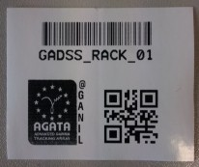
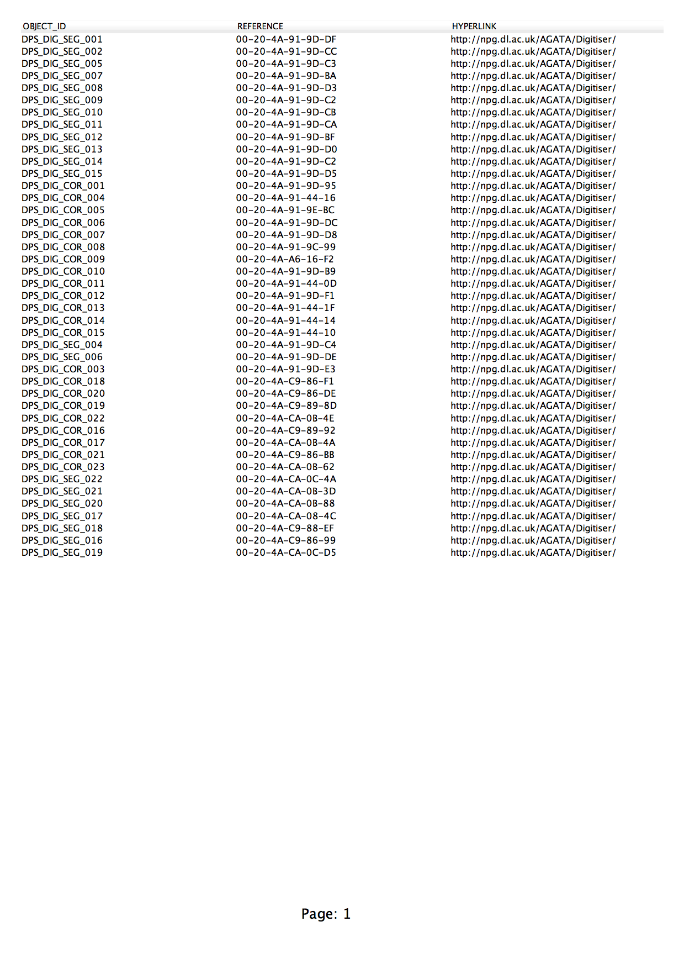

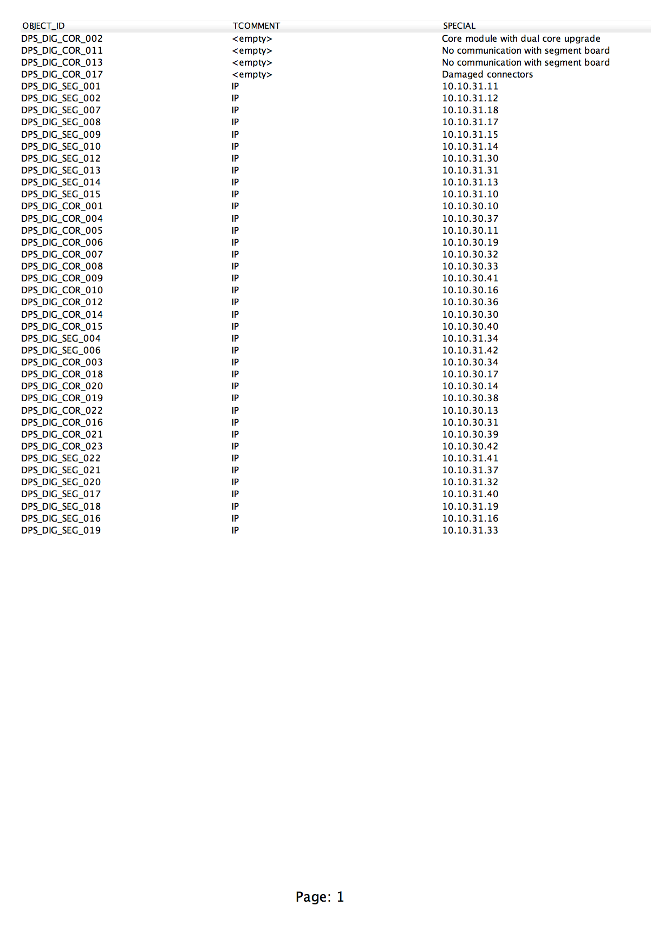

From http://www.ikp.uni-koeln.de/~bartb/AGATA_Manuals/overview.xlsx (04/02/2013)
From overview.xlsx file on the Cologne's web site 29/10/2013

